READ ME
- Open the excel document DCP_SCREEN.xls.
- This excel workbook contains 11 work sheets.
- The names of all the worksheets are as follows:
- Biodata page 1
- Biodata page 2
- Other information
- Sheet Previous Qualifying and Foreign Service
- History & Verification
- Leave
- LTC
- Nominations
- Training and Examination
- Asset and Quarter Details
- Loan/Advance Details

- You have to enter your employee Id in the employee Id field which is present in the Sheet1 (refer Biodata page1) and click on the GET DATA button at the bottom of the sheet.

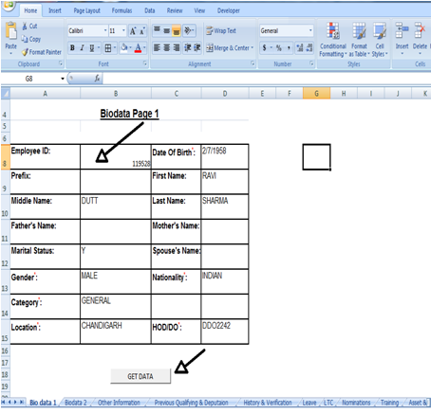
Biodata Page 1
- On click all the details for that particular employee Id gets updated to the corresponding sheets.
- You can then print your details using the key combination (Ctrl+P) ,then a screen will appear (refer print screen) and select Entire workbook option and the click OK button.

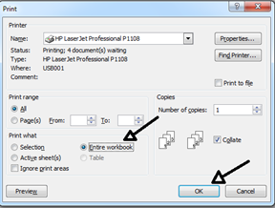
Print screen

